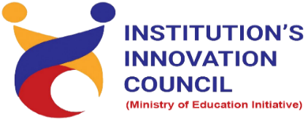
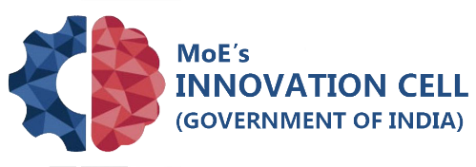
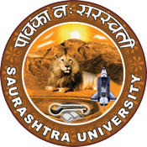
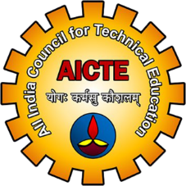

Idea to Product
20 June 2022
At
Virtually on Webex
Saurashtra University Campus, Rajkot
Contents
Saurashtra University – IIC 2
Event Schedule 2
Event Registration Link 2
Brief about Event 3
Key Points 3
Outcome 3
About the Speaker/Chief Guest 4
Connect Us: 6

Saurashtra University – IIC
The university is dedicated to instruction, research, and extending knowledge to the public (public service). Ministry of Education (MoE), Govt. of India has established ‘MoE’s Innovation Cell (MIC)’ to systematically foster the culture of Innovation among all Higher Education Institutions (HEIs). The primary mandate of MIC is to encourage, inspire and nurture young students by supporting them to work with new ideas and transform them into prototypes while they are informative years. Saurashtra University is one the Organization that have constituted the IIC to foster the vision of MoE and be a part for the promotion and development of innovation ecosystem.

Event Schedule

Event Registration Link

bit.ly/ImpactSeries-IIC

Brief about Event
Saurashtra University is Organizing Impact Lecture Series with support of Ministry of Education, Government of India. The objective of Impact Lecture Session is to support students from hilly/rural/backward regions or 3rd tier cities by organizing impact lectures to establish a strong connection with the innovation and start up ecosystem enablers at the state and national levels.
The webinar’s objective is to gain insights in a product design thinking process to carry out some form of prototyping. This involves clear vision about product, strategy of the product, work of the product and scaled down version of the product in order to reveal any problems with the current design. Innovators should focus on users firstly then focus on business and technology.
After completion of the workshop, participants are able to acquire more knowledge on Idea to product.
● Finding your product-market fit
● Adding value for end users
● Ways to attract investors
● How to refine your product designs

Key Points

During the session, below mentioned points were discussed:
- Factors effect product design
- Structuring your ideas
- The spiral approach
- Finding the problems & identify problems
- Design thinking
- Stages of the product
- FAQs related to Idea to Product

Outcome
As per the event, various types of Product design, Importance of Product and Idea selection criteria was made understood by the speaker.
Also, as it was related to Product design and awareness creation, a basic knowledge of how to design product, how it works, how to develop prototype model, with various examples of product design and research etc.

About the Speaker/Chief Guest

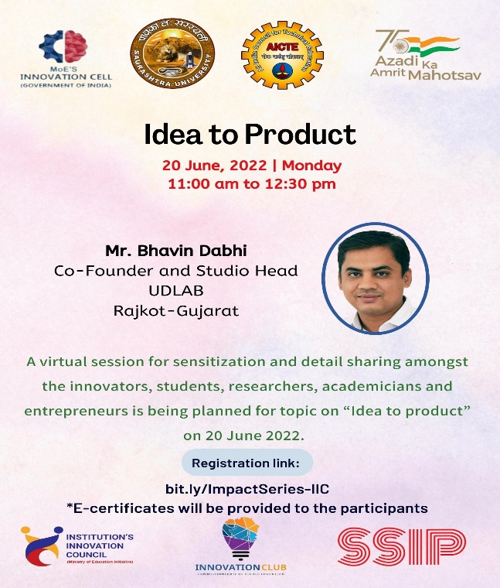

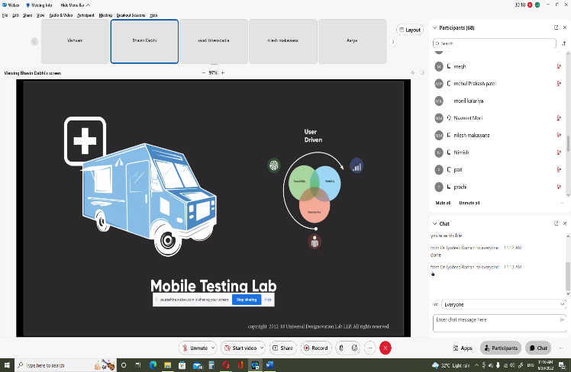
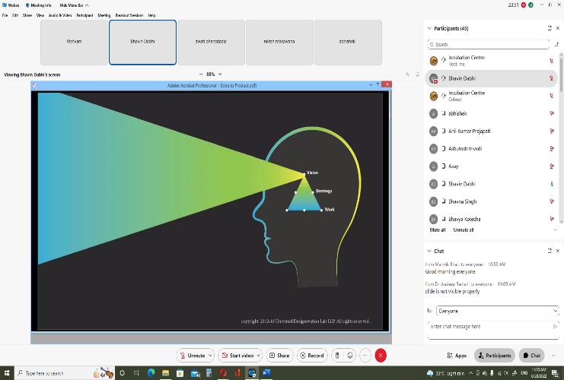

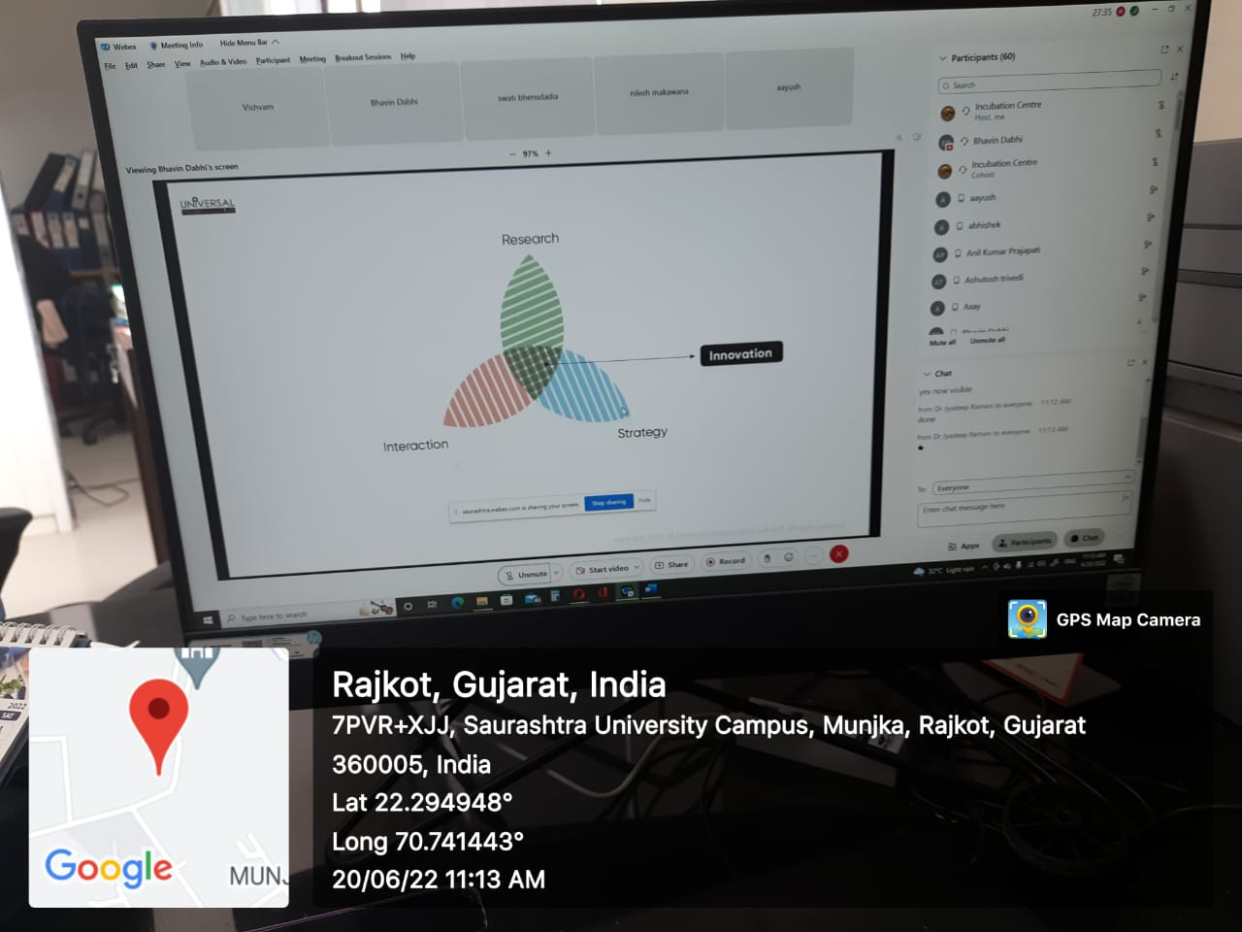
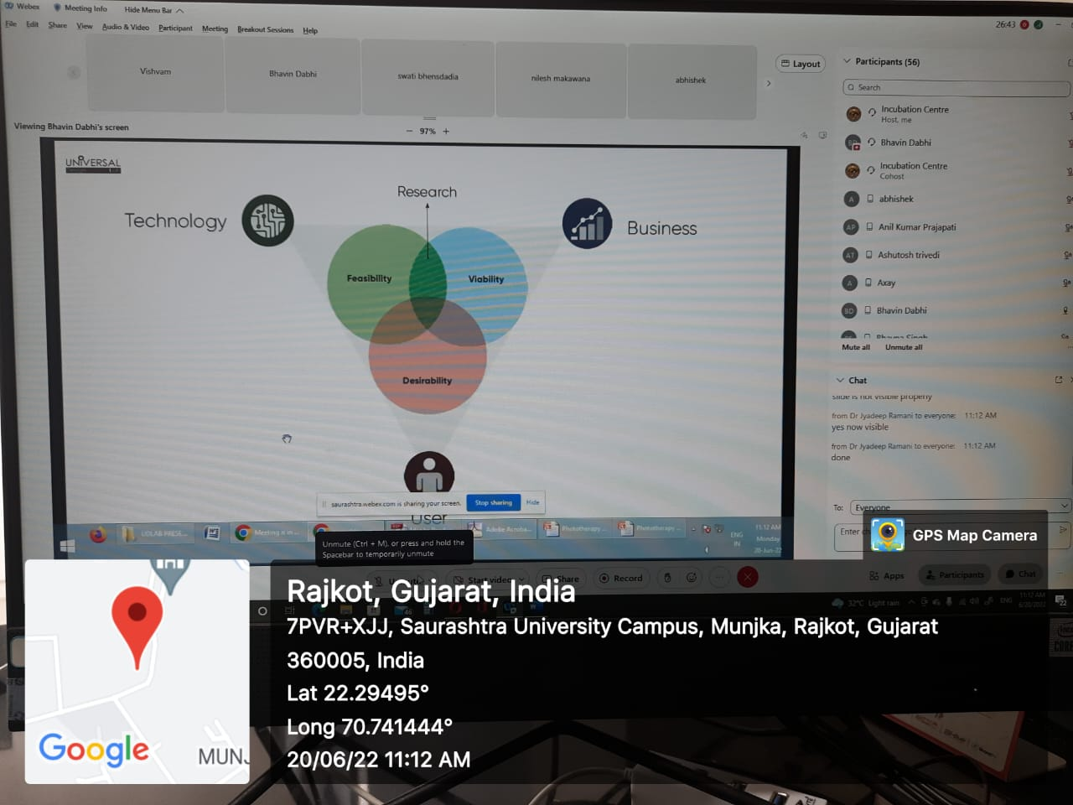
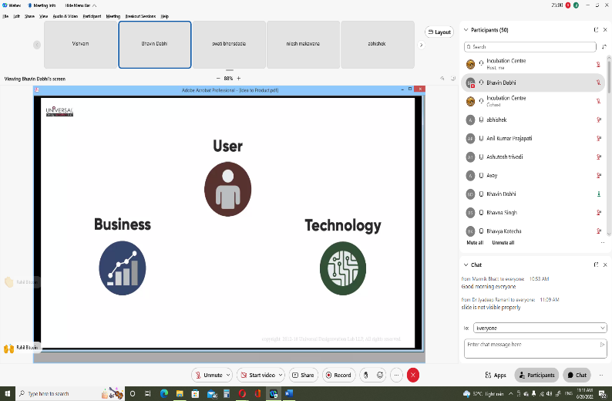
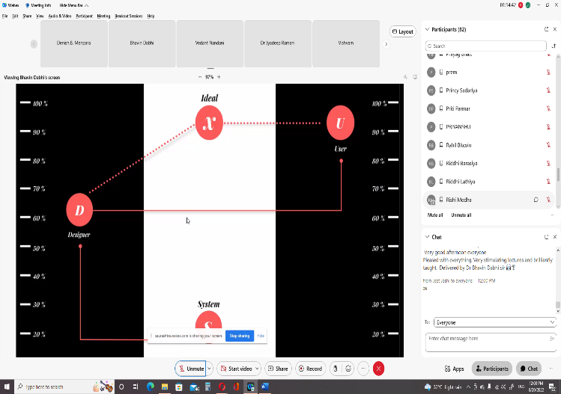

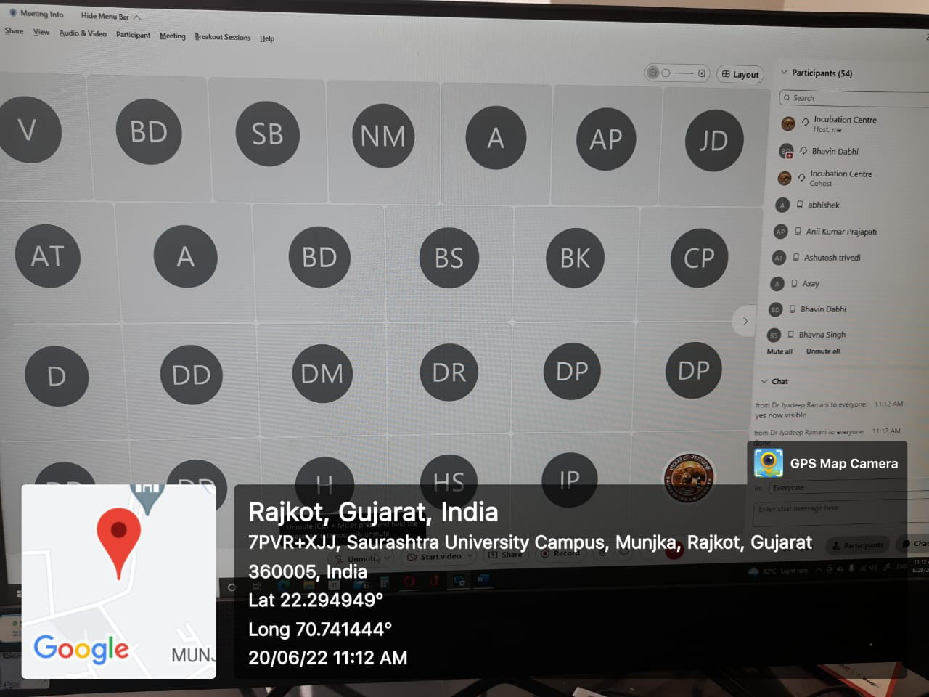

Connect Us:

https://www.linkedin.com/company/susec iic@sauuni.ac.in
https://www.facebook.com/iicsauuni bit.ly/SU-SSIP Location
https://www.instagram.com/susecrajkot https://bit.ly/SUSEC-youtube

